VISHAAL SV 1924123459 ECA0502 EMF

Exp:7- Determination and plotting of Capacitance of isolated and concentric sphere with different inner and outer radius and dielectric constant of the dielectric mediums.
PROGRAM:
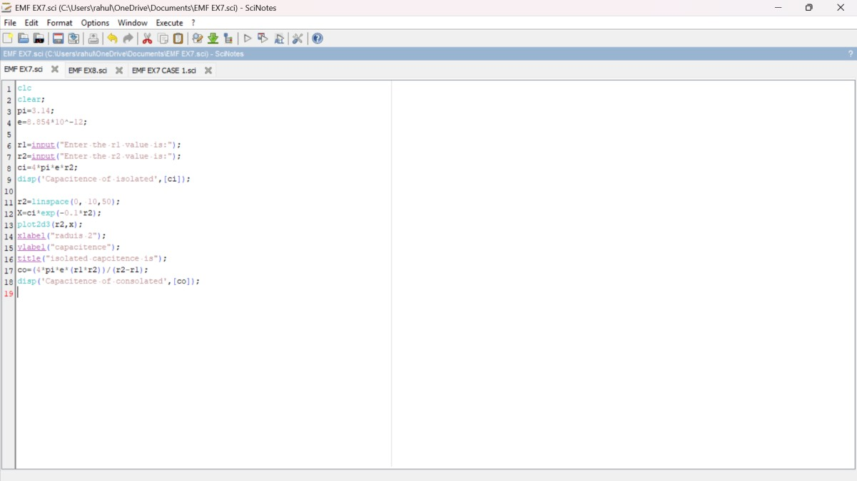
OUTPUT:
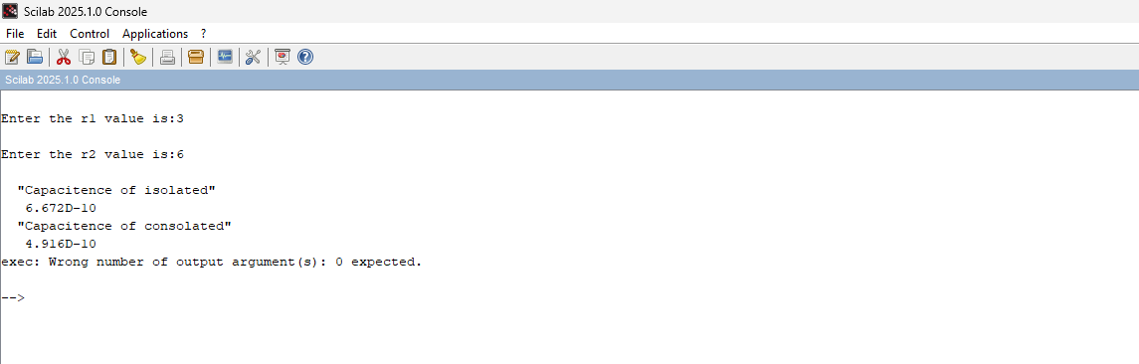

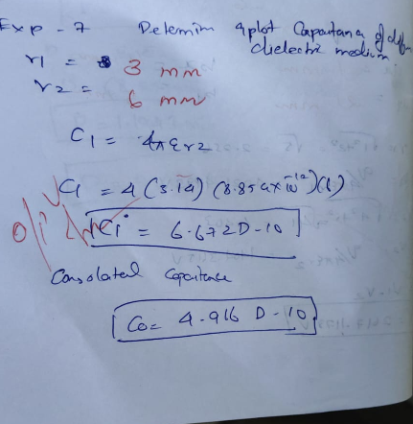
CASE 1:
PROGRAM AND OUTPUT:
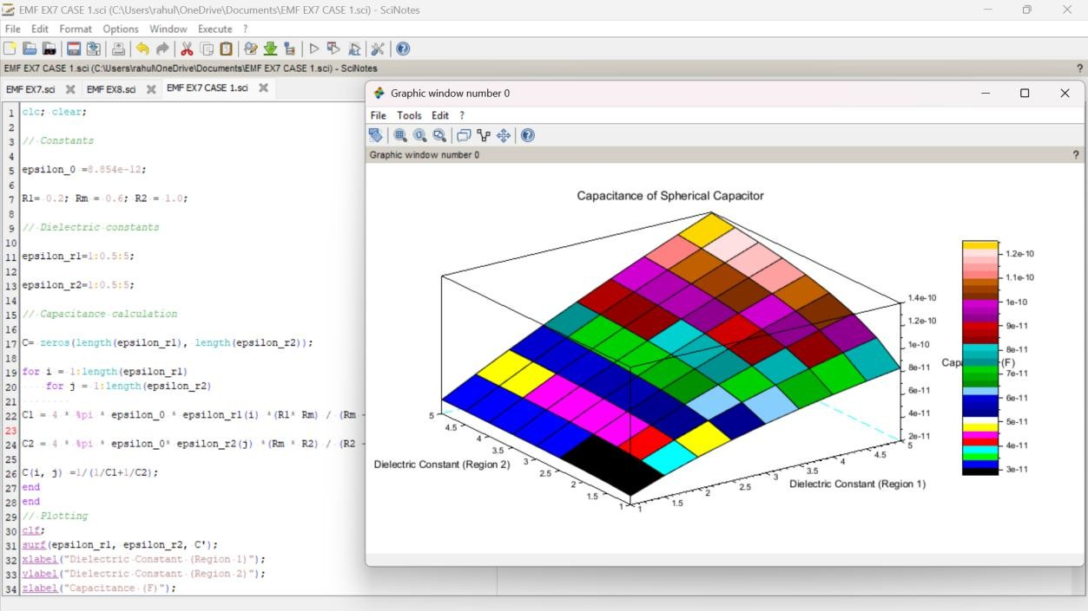

CASE 2:PROGRAM AND OUTPUT:
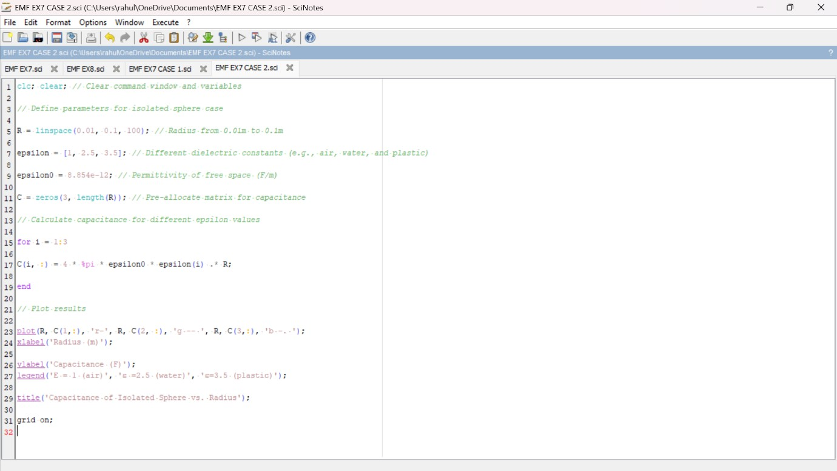
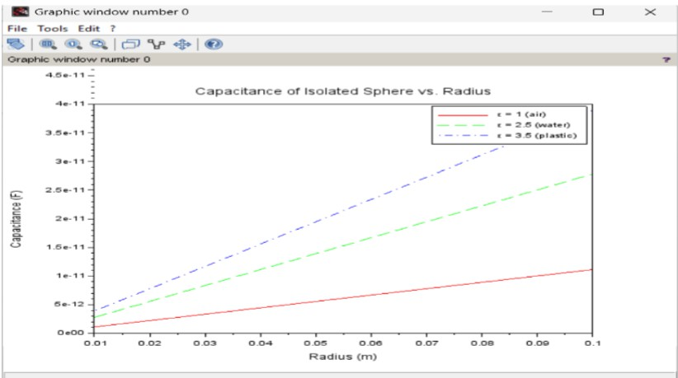

CASE 3:
PROGRAM AND OUTPUT
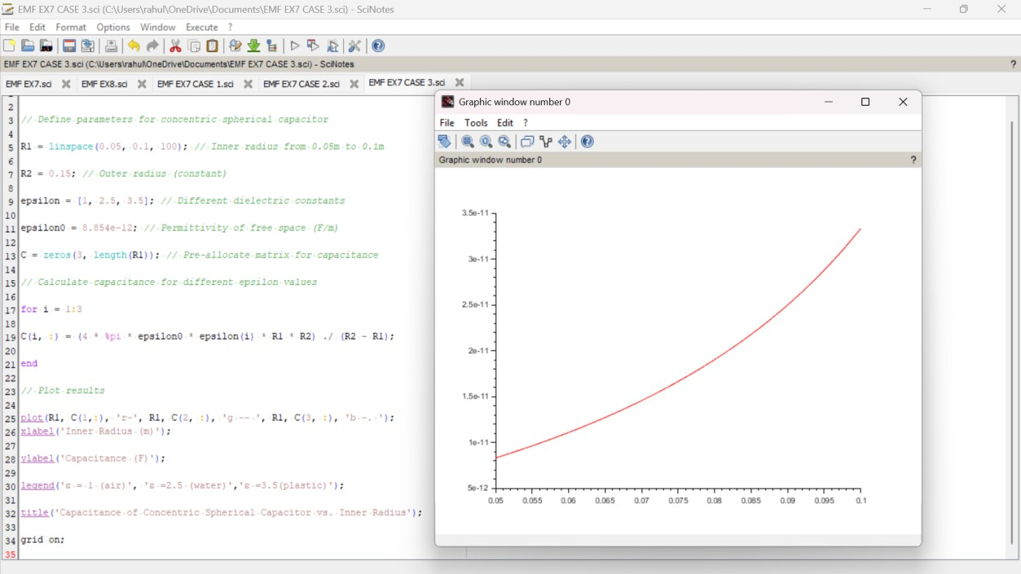

Calculations:
